**Crowdfunding Campaigns Data Analysis Report**

* Given the provided data, what are three conclusions that we can draw about crowdfunding campaigns?

1. “Plays” is the most popular project.
2. 78% of the projects have more than 50% successful Outcome.
3. Mid-range goals are more successful in comparison to lower and higher range.

* What are some limitations of this dataset?

1. The sample set of data provided is very limited and can’t be sure if it is well distributed; hence, some of our conclusions could be biased based on the data provided.
2. There is a possibility of some of the most important data during the collection phase not being measured.
3. The source of the data could not be completely relied upon.
4. Some of the fields could have been assumed to be something else that it might not refer to.

* What are some other possible tables and/or graphs that we could create, and what additional value would they provide?

1. Can analyse data based on Country as well.

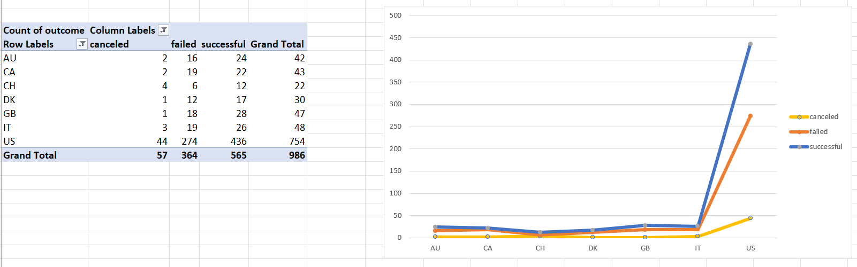

* 1. We could analyse from this chart that US has the highest number of backers (we are assuming that the Country field is in reference to the donations made).
  2. We can identify where a greater number of Backers are from and potential countries that could contribute more. For example, GB could have more backers based on their economy and population.

1. Can analyse data pertaining to each Sub-Category based on the Parent Category, which could help provide a detailed analysis of each project.
2. Can analyse data based on the Country and Year.

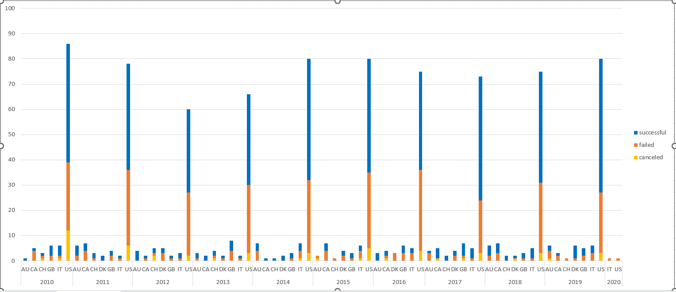

* 1. Using this chart, we can determine whether the ratio of successful to unsuccessful projects is high or low by each Year, for a particular Country.
  2. This analysis could maybe help determine the economical situation of that country during a particular Year, as the number of Backers could/could not provide funding.

1. A detailed analysis of each Outcome could be derived based on the Year as well as the Sub-Category.